**DS NOTE 3:**

**Queue:**

We are more familiar with queues than we are of any other data structure. Whether be it the queue for buying an iPhone or movie ticket or a queue for the khichidi that is served after Saraswati puja.

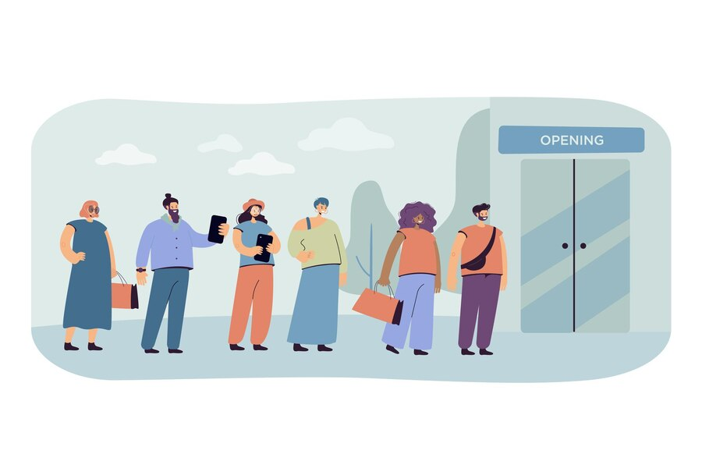

Imagine a queue and how it functions. If you are the first one in the line you get the khichidi first but when your friends come to join the line they have to stand at the end of the line or everybody else will start screaming. This property of a queue is known as First in First out or FIFO.

There are two ends of a queue, the elements in the front end of the queue will get out first and whenever a new element wants to join the queue, then it has to join the back end.

**Definition:** We define a queue to be a list in which all additions to the list are made at one end, and all deletions from the list are made at the other end. The element which is first pushed into the order, the delete operation is first performed on that.

There are two basic operations related to a queue:

1. Enqueue (*or Insert per your syllabus*): This operation means adding an element to the end of the queue.
2. Dequeue (or delete per your syllabus): This operation means to remove an element from the queue.

This is how a queue looks like. It is very similar looking to a 1-D array but it’s the characteristics that make it special.

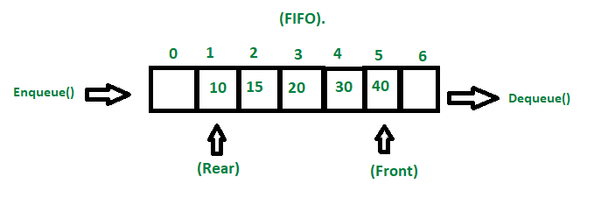

**Note:** This is nowhere near the end of queue and there are a lot of things to learn about it like types of queues and more operations but we are limited by your syllabus and is not necessary at this point.

**This marks the End of Unit 2 of your syllabus.**